CEN 4010 Principles of Software Engineering, Summer 2023

**Milestone 3: Detailed Requirements, Architecture and a Vertical Software Prototype**

Tastebudz is an innovative web application that revolutionizes the way users create unique and delightful food recipes. TasteBudz aims to empower users by providing them with a personalized experience, enabling them to discover and craft delicious meals based on the ingredients they already have in their fridges. With the ability to create accounts and save recipes, TasteBudz will become a go-to platform for culinary enthusiasts, home cooks, and anyone else seeking inspiration in the kitchen.

Team: Group 8

Project: Tastebudz

Students:

Logan Karstens - lkarstens2021@fau.edu

Divyesh Mangapuram - dmangapuram2015@fau.edu

Colton Rohan - crohan2020@fau.edu

Brandon Pojoga - bpojoga2019@fau.edu

Rohit Varghese - [rvarghese2021@fau.edu](mailto:rvarghese2021@fau.edu)

7.18.23

**Vertical Software Prototype**

**Youtube :** [**https://youtu.be/HYU2aIhz-Ug**](https://youtu.be/HYU2aIhz-Ug)

**History Table**

| **Revision Date** | **Revision Description** |
| --- | --- |
| 7.13.23 | Began working on the document and minor completion of some content |
| 7.14.23 | Major completion of document content and website coding |
| 7.15.23 | Further completion of content and addition of diagrams |
| 7.16.23 | Completetion of content and diagrams. Each member given chance to review |
| 7.18.23 | Completed vertical prototype, final revisions for submission |

**TABLE OF CONTENTS**

Title page..…………………………………………………………………………………………1

History Table………………………………………………………………………………………2

Executive Summary……………………………………………………………………………….4

Competitive Analysis ……………………………………………………………………………..5

Data Definition………………………………………………………………………………...….8

Overview, Scenarios, and Use Cases………………………………………………….….……...14

High-Level Functional Requirements ……………………………………..………………...…..16

Non-Functional Requirements.………………………………………………………………..…17

High-level System Architecture and Database Organization…...………………………….……18

High-level UML Diagrams………………………………………………………………………21

Risks.……………………………………………………………………………………………..26

**Executive Summary**

TasteBudz is an online platform designed to revolutionize the way people approach cooking and meal planning. The application uses its hand crafted features to empower people of all skill levels to explore their creativity in the kitchen. By using a powerful API and intuitive toolset TasteBudz provides an easy to use experience that anyone can use to create useful recipes.

The main functionality of TasteBudz is focused on its recipe search engine supported by a useful API. The API offers developers access to a large amount of detailed food-related data including over 360,000 recipes. This massive amount of API support allows for advanced search capabilities and value-added services such as meal planning and price estimation.

TasteBudz stands out in the competitive food technology landscape due to its easy to use design and powerful API. While other platforms may offer similar features very few combine the level of detail and range of functionality that TasteBudz offers. Its intuitive interface ensures a user-friendly experience that will guide individuals through the process of discovering new recipes.

Looking ahead, TasteBudz will continue to innovate and expand to meet the evolving needs of its users. Personalization will be a key focus, with individualized meal recommendations and detailed nutritional analysis becoming even more prominent. Additionally, TasteBudz sees opportunities to integrate with smart kitchen appliances, enabling users to receive recipe suggestions and nutritional information directly through these devices.

In conclusion, TasteBudz is poised to be a leading player in the intersection of food and technology. Its comprehensive database, powerful API, and user-centric features position it as a unique solution for accessing detailed food-related data. Whether for developers, businesses, or individuals, TasteBudz caters to a wide range of needs and provides personalized cooking solutions that empower culinary creativity. As the food tech sector continues to grow, TasteBudz is well-positioned to capitalize on future trends and solidify its position as a go-to platform for food enthusiasts worldwide.

**Competitive Analysis**

| **Platform** | **Recipe Database** | **User Interface** | **Additional Features** | **Price** |
| --- | --- | --- | --- | --- |
| **Spoonacular** | Curated collection | Traditional and intuitive | API services, menu planning / shopping tools | Free for small quantities, paid per additional request |
| **Yummly** | Curated collection | Traditional and intuitive | Menu planning / shopping tools | Free, supported by advertising |
| **AllRecipes** | User Generated | Varied, user-friendly | Menu planning tools, recipe collections | Free, supported by advertising |
| **Tasty** | Curated collection | Video-based, visual | Recipe videos | Free, supported by advertising |
| **Food.com** | User Generated | Traditional and intuitive | Menu planning tools, recipe collections | Free, supported by advertising |
| **BigOven** | Wide range of recipes | Traditional and intuitive | Menu planning tools, recipe collections | Free, supported by advertising |
| **Edamam** | Curated collection | Traditional and intuitive | API services, menu planning tools | Free limited API calls/day, paid excess use |
| **Epicurious** | Curated collection | Clean and intuitive | Cooking tips and videos, personalized recipe box | Free, supported by advertising |
| **Martha Stewart Recipes** | Curated collection | Elegant & user-friendly | Seasonal and holiday recipes, cooking techniques, meal planning tools | Free, supported by advertising |

This tabular analysis will focus on six components: homepage, navigation, content, design, usability, and retention, each of which are defined in the data definition section. Each competitor is given a score from 1-5 in each category to represent effectiveness.

|  | **TasteBudz** | **Yummly** | **AllRecipes** | **Tasty** | **Food.com** |
| --- | --- | --- | --- | --- | --- |
| FrontPage | 5 | 4 | 5 | 3 | 5 |
| Navigation | 4 | 3 | 4 | 4 | 4 |
| Content | 5 | 5 | 4 | 4 | 5 |
| Design | 4 | 4 | 5 | 5 | 4 |
| Usability | 5 | 3 | 3 | 4 | 3 |
| Retention | 3 | 4 | 3 | 3 | 4 |
| **Average** | **4.3** | **3.8** | **4.0** | **3.8** | **4.1** |

**In-depth Analysis**

[www.yummly.com](http://www.yummly.com) - 3.8 / 5

Yummly offers similar features such as its extensive recipe collection and personalized recommendations. The frontpage is very cluttered and can make users uncertain about where they want to go on the site. The application does not offer a navigation bar at the top of the screen but rather to the left side of the webpage, which can feel more intrusive than a traditional navigation bar.

[www.allrecipes.com](http://www.allrecipes.com) - 4.0 / 5

Allrecipes focuses on an excellent frontpage and design that looks very professional while still being playful in nature. The problems with the site stem from its usability. Moving from recipe to recipe is unintuitive and hard to manage. Pop-ups frequently interrupt the website experience. In addition, the content is less curated than some competitors; there are many types of food missing completely.

[www.tasty.co](http://www.tasty.co) - 3.8 / 5

Tasty is a unique website that offers interesting features, such as drop down nutrition information that allows users to opt into nutritional constraints or the ability to add ingredients to your online walmart cart. The frontpage is unprofessional, containing a user submitted picture that takes up a majority of the screen along with clickbait articles. Retention also is a problem because a majority of the content appears to be clickbait or “presented by walmart” which causes the website’s success to depend on a separate company.

[www.food.com](http://www.food.com) - 4.1 / 5

Food.com is a well-organized website that is both content rich and well designed in the front page. One big issue, though, is the search bar within the website. Competing websites enable users to search while staying the page of a separate recipe. Food.com, however, forces you to access a separate page to use the search function. This is very inconvenient and unintuitive for the user. This frustration would deter some users from the website altogether, lowering retention.

**Data Definition**

| **Data Entity** | **Description** |
| --- | --- |
| **Recipes** | |
| Recipe ID | A unique identifier for each recipe. |
| Recipe Name | The name or title of a specific recipe. |
| Description | A detailed description or summary of the recipe. |
| Ingredients | The list of ingredients required to prepare a recipe, including their names and quantities. |
| Preparation Steps | Detailed step-by-step instructions for preparing the recipe. |
| Cooking Time | The estimated duration required to complete the cooking process for the recipe. |
| Preparation Time | The estimated duration required for the preparation stage of the recipe. |
| Total Time | The total estimated time required to complete the recipe, including both preparation and cooking time. |
| Serving Size | The recommended number of servings a recipe is intended to yield. |
| Difficulty Level | An indication of the recipe's difficulty level, such as easy, medium, or advanced. |
| Cuisine | The culinary tradition or style associated with the recipe. |
| Dietary Information | Information related to dietary considerations, such as vegetarian, vegan, gluten-free, or allergen-free labels. |
| Nutritional Information | Comprehensive data on the nutritional composition of the recipe, including macronutrients (carbohydrates, proteins, fats), micronutrients, vitamins, minerals, and calories per serving. |
| Ratings and Reviews | User-generated feedback, ratings, and written reviews for the recipe. |
| **Ingredients** | |
| Ingredient ID | A unique identifier associated with each ingredient. |
| Ingredient Name | The name or title of a specific ingredient. |
| Description | A detailed description or overview of the ingredient. |
| Culinary Uses | Information on the typical culinary uses and applications of the ingredient. |
| Dietary Attributes | Information indicating dietary classifications, such as vegan, vegetarian, gluten-free, or allergen-free. |
| Substitutes | Recommendations for alternative ingredients that can be used as substitutes for the ingredient. |
| **Nutrition** | |
| Macronutrients | Detailed information on the composition of carbohydrates, proteins, and fats in recipes and ingredients, including specific values per serving. |
| Micronutrients | Comprehensive data on the presence and quantity of vitamins, minerals, and other essential nutrients in recipes and ingredients. |
| Calorie Content | The total number of calories present in recipes or associated with specific ingredients per serving. |
| **User-Generated Content** | |
| User Profiles | Individual user accounts created on Spoonacular.com, which may include personal information, preferences, and activity history. |
| Ratings and Reviews | User-submitted ratings and written reviews for recipes, providing insights and opinions on their quality, taste, and modifications made. |
| Comments and Discussions | User-generated comments, discussions, and interactions on recipes, ingredients, cooking techniques, and related topics. |
| **Search Results** | |
| Query Results | The outcomes generated by user searches on Spoonacular.com, encompassing relevant recipes, ingredients, articles, videos, cooking tips, and other content based on search criteria. |
| **Interactive Features** | |
| Meal Planning | Tools and functionalities for creating, organizing, and scheduling meal plans using recipes from Spoonacular.com. This includes customizable meal plan duration, meal schedule, and integration with grocery lists. |
| Shopping Lists | The ability to generate and manage grocery lists based on selected recipes or user preferences. It includes ingredient names, quantities, and potentially additional details like aisle numbers for easy shopping. |
| **Quality Measures** | |
| Homepage | The main page and starting point of a website. Measured by the aesthetic, professionalism, and feature access from this page. |
| Navigation | The ease of movement between different pages in a website. Measured on the intuitive use of the website and access of its features. |
| Content | The range of information and media on a website. Measured by quantity and quality of recipes present. |
| Design | The visual arrangement of the service. Measured by overall aesthetic and professionalism for the website. |
| Usability | The ease of use and efficiency when interacting within the website. Measured on intuitive layout and availability of desired content |
| Retention | The ability to keep users actively interacting with services. Measured by the likelihood of a customer staying on the website or using it again. |

**Overview, scenarios and use cases**

**Overview**

TasteBudz is an innovative and comprehensive platform designed to empower users in creating delicious meals based on their available ingredients. With a focus on meeting diverse dietary specifications and culinary preferences, our platform offers a range of features to enhance the cooking experience. By integrating Spoonacular's API, we can leverage its extensive food, recipe, and nutrition database, providing users with a reliable and comprehensive resource.

**Scenarios**

Blogging: Culinary bloggers can elevate their content by incorporating TasteBudz into their posts. Users can enrich their recipes with precise nutritional breakdowns, catering to health-conscious readers and providing valuable information.

E-commerce: For online grocery stores, TasteBudz offers a unique value proposition, as they can utilize our platform to provide an extensive recipe library along with personalized shopping recommendations based on selected recipes. This integration enhances the user experience, offering customers convenience and inspiration for their grocery shopping.

Meal Planning Service: Meal planning businesses can optimize their services by leveraging TasteBudz. Our platform grants access to a vast recipe database and detailed nutritional information, enabling businesses to curate personalized meal plans tailored to individual dietary needs, preferences, and budget considerations.

Dietary Management: Healthcare providers developing web-based tools for dietary management can benefit from TasteBudz, which can provide nutritional analysis of meal plans. This can help patients effectively manage their dietary restrictions and health conditions.

App Development: In the future, TasteBudz will seamlessly integrate into health and fitness apps, enabling users to log their meals and directly track their nutritional intake. The platform will provide detailed and accurate nutritional information for a wide array of foods, ensuring users have reliable data for their dietary management.

**Use Cases**

Nutritional Analysis: TasteBudz, powered by Spoonacular's API, offers comprehensive and reliable nutritional data for individual food items and recipes. This feature is invaluable for health and fitness apps, empowering users to track their nutrient intake accurately. It also supports professionals such as dieticians and nutritionists in designing personalized diet plans based on precise nutritional information.

Recipe Search: TasteBudz boasts an expansive recipe database, accessible through Spoonacular's API. Users can effortlessly search for recipes based on specific dietary criteria, available ingredients, or culinary preferences. This functionality streamlines the process of finding suitable and enjoyable recipes, enhancing user satisfaction.

Meal Planning: With TasteBudz, users can generate personalized meal plans tailored to their dietary preferences, nutritional requirements, and budget constraints. Spoonacular's API facilitates this feature by providing recipe suggestions and creating shopping lists, offering users a convenient and tailored meal planning experience.

Price Estimation: TasteBudz, in collaboration with Spoonacular's API, equips users with recipe cost estimates. This functionality proves beneficial for businesses such as restaurants or catering services, enabling accurate calculation of meal costs. Additionally, budget-conscious users and those focused on healthy eating on a budget can leverage this feature for financial planning.

Dietary Preference Management: TasteBudz allows users to filter recipes based on various dietary restrictions and preferences, such as vegetarian, vegan, gluten-free, and more. Through integration with Spoonacular's API, users can easily discover recipes aligned with their specific dietary needs, fostering inclusivity and accessibility.

Ingredient Substitution: TasteBudz, powered by Spoonacular's API, provides users with recommendations for ingredient substitutions. This functionality proves invaluable for users with dietary restrictions, allergies, or limited ingredient availability, offering flexibility and adaptability in their culinary endeavors.

**High-level functional requirements**

**Priority Level 1**

User Login: This feature is crucial as it forms the basis of our personalized service offerings. It will allow users to create and log in to their accounts on the platform. This personalized access will enable features such as saving favorite recipes and engaging with the community, fostering a more connected and personalized user experience.

Add, Delete, View, List Favorites: This functionality will offer users the flexibility to customize their experience by adding recipes to their favorites list and deleting them when no longer needed. It will also allow users to organize and access their preferred recipes easily, further enhancing the personalization aspect of our service.

Search and Filters: Our platform will incorporate sophisticated search and filter capabilities, enabling users to discover recipes that align with their specific preferences, dietary needs, and available ingredients. This feature will significantly enhance the user's ability to customize and personalize their culinary journey.

**Priority Level 2**

Recipe Information: To ensure users can accurately follow and recreate our recipes, we will provide detailed information, including a list of ingredients, videos, and step-by-step directions. This feature emphasizes our commitment to user engagement and satisfaction.

Nutrition Information: In keeping with our focus on health and well-being, we will offer detailed nutritional information for each recipe. This empowers users to make informed decisions about the recipes they choose based on their dietary goals or restrictions.

**Priority Level 3**

Community Interaction: Retention and user satisfaction can be improved by creating a vibrant and engaging community of users who can share their culinary experiences, rate recipes, and post reviews. This feature will be available to logged-in users, further emphasizing the value of having a personal account. It will also contribute to the decision-making process for other users as they choose which recipes they want to try.

**Non-functional requirements**

Simple Design: At the heart of our platform is the commitment to simplicity and ease-of-use. We understand that an intuitive, user-friendly design significantly enhances user experience. Therefore, we aim to build a platform that new users can navigate effortlessly, fully utilizing all functionalities without any issues. Rest assured, we are dedicated to maintaining a clean and focused interface, free from distractions such as advertisements.

Manageable Performance: Speed is a vital attribute for any digital platform. Our commitment is to maintain optimal performance levels, ensuring minimal delays in data loading. To achieve this, our connection with the database will reside at the highest order component, enabling quick content loading and addition. While our site is not a real-time system, we understand that long loading times can deter users, and we are keen to prevent this.

Security: A cornerstone of our platform is the security of our users' data. We plan to utilize the latest encryption software to safeguard user information. Regular security audits will be conducted to prevent unwanted web traffic and potential breaches. We aim to earn and maintain our users' trust, encouraging them to safely share personal details like payment methods with us.

Accessibility: The TasteBudz platform will prioritize accessibility. Our design will consider individuals with impaired vision, using colors that enhance readability. We will avoid any colors that detract from legibility or distract from the website's purpose. Moreover, our website will be compatible with all major web browsers and feature a responsive design that ensures seamless operation across a variety of devices.

Scalability: Our platform will be built with scalability in mind. We aim to handle increasing user demand and a growing repository of recipes without compromising on performance. The frameworks we employ will facilitate this scalability, ensuring our platform remains robust even as our user base expands.

Reliability: A reliable service is a respected service. Post-major development, we will ensure that our platform experiences minimal downtime, if any. Our robust backup system will ensure that even in the unlikely event of a system failure, the site will have a reliable method to restart itself.

**High-level System Architecture and Database Organization**

**Client-Side Components**

User Interface: Our platform manifests a visually appealing, user-friendly interface that is not just designed to render the TasteBudz website, but also to provide an interactive user experience. Our goal here is to ensure that users can easily navigate through our website, making their journey as seamless as possible.

User Input: We place immense value on user interaction, hence, we've integrated efficient systems to accept and process user inputs. This covers ingredient selection, recipe customization, and other user interactions, which forms the basis of our customized, user-centric offerings.

**Server-Side Components**

Web Server: Serving as the backbone of our operations, our web server is designed to handle client requests effectively. It manages routing and ensures the delivery of appropriate responses, underlining the seamless functionality that we aim for.

Database: Our database serves as the repository for storing valuable data such as recipe information, user profiles, saved recipes, and other relevant information. The database allows for persistent storage and efficient data retrieval, a key aspect of providing quick and personalized services to our users.

**Third-Party Integrations**

Social Media Integration: Our platform leverages Firebase technology to offer social media connectivity. This integration allows users to connect their TasteBudz account to various social media platforms, enabling them to share recipes and engage with the TasteBudz community, thereby enhancing the social aspect of our service.

Security: By using Google’s Firebase Authentication, users can easily link their Tastebudz accounts to other accounts with thorough 2+ factor authentication, allowing for top-level security without the expenses of creating and maintaining it ourselves.

**Database Organization**

This project’s database will be non-relational and use MongoDB to store application data. The data will be organized into the following collections:

Users: Information pertaining to the user and the user only. Includesuser_id, username, encrypted password, and optional firebase token.

UserFavorites: Associates users and the spoonacular recipe IDs they favorite. Includes favorite_id, user_id, and recipe_id.

LastRecipes: Associates users and their most recently viewed recipe. Includes lastrecipe_id, user_id, and recipe_id.

UserRecipeComments: Stores comments made by users on recipes. Includes comment_id, recipe_id, user_id, parent_comment_id, comment_content, likes, and dislikes.

Optional future tables:

UserIngredients: Associates users and their most recently selected ingredients. Includes useringredient_id, user_id, and ingredient_id.

UserNutrients: Associates users and their most recently selected nutrients. Includes usernutrient_id, user_id, nutrient_id, min_quantity, and max_quantity.

Note: Recipe, ingredient, and nutrient information is all retrieved via the spoonacular API, and thus does not need to be stored in our database.

**File Systems**

Media Storage does not need to be considered in our project, so a file system is not necessary. Images depicting recipes, recipe instructions, ingredients, and nutrients are all retrieved through the spoonacular API. Potentially, user profile pictures could be included in the future, and if so, this section will be changed accordingly.

**Search/Filter Architecture**

Most of the searching and filtering will leverage spoonacular’s API. Searching will be divided into three main categories:

Ingredients: Users can select a list of ingredients and will receive recipes that can be created using those ingredients.

Nutrients: Users can select constraints on nutrients and will receive recipes that match all of those constraints.

General: Users can search recipe by name (and potentially other attributes, such as cuisine) and receive recipes associated with the selected attributes.

The only search functions we will have to fully implement are for the favorites. For our initial implementation, users can simply search through their favorites by name and will receive all recipes that include the entire search term somewhere in the recipe name. This also includes room for future expansion.

**Our APIs**

We need API’s that can act as a middleman between the front-end and the spoonacular service. Therefore, each spoonacular API route we utilize in TasteBudz will have its own dedicated API route in our backend. This includes searching recipes by name, ingredient, and nutrition. In addition, we need to implement our own APIs for the following:

* Create, Read, Update, Delete (CRUD) Operations on user favorites
* CRUD Operations on recipe comments

**High-level UML Diagrams**

**Class Diagram**

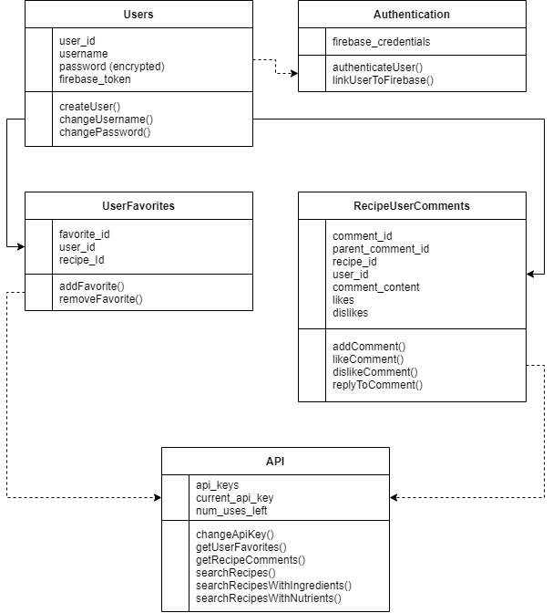

**Use-Case Diagrams**

Authentication

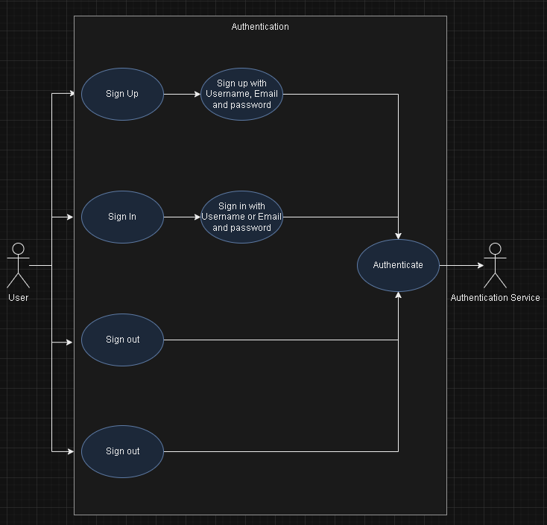

Favorite

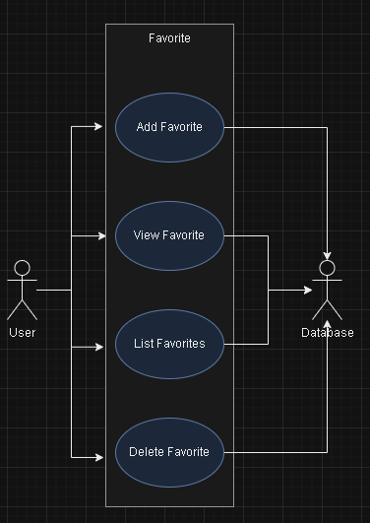

Search

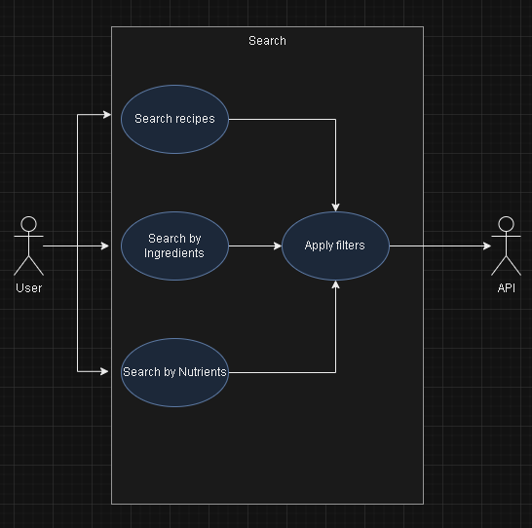

Community Interaction

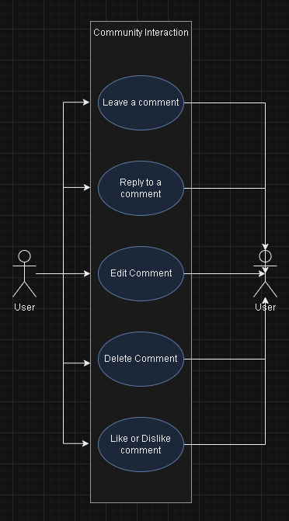

**Risks**

**Skill Risks**

Problem: A subset of our team members lacks requisite expertise in web and full-stack development.

Solution: We will utilize a knowledge-sharing approach, enabling our more experienced members to guide the development process, while also providing learning opportunities for those less skilled. For the latter, independent research and learning can help enhance their abilities, consequently bolstering overall team performance.

**Schedule Risks**

Problem: Our team is currently grappling with diverse responsibilities, including jobs and multiple academic courses. As we approach the end of the semester, these commitments are increasingly overlapping.

Solution: Our resolution to this issue hinges on robust and clear communication. We commit to regular discussions to delegate tasks effectively, allowing each member to work autonomously. This strategy ensures task completion within the constraints of each member's schedule while maintaining project momentum.

**Technical Risks**

Problem: The complexities of developing a website start at which include data management, API integration, and ensuring security, pose significant technical challenges. The risk is further exacerbated by the potential for performance issues that could impact user experience and the reliability of our platform.

Solution: To manage these technical risks, we plan to adopt a multi-faceted strategy. For robust data management and security, we will deploy secure coding practices and implement strong encryption protocols for data at rest and in transit. We also plan to conduct regular security audits to identify and rectify potential vulnerabilities. When it comes to API integration, we will follow industry best practices and possibly engage middleware or integration platforms for efficient integration. To optimize performance and reliability, we'll incorporate effective database optimization techniques, lean coding practices, and regular performance testing to promptly identify and eliminate any bottlenecks. By adopting this comprehensive approach, we aim to minimize technical risks and ensure the reliable, secure, and efficient operation of our platform.

**Teamwork Risks**

Problem: Team cohesion may be impacted due to the fact that several members have not met prior to the initiation of this project, and may not be familiar with each other's preferences.

Solution: Our approach involves establishing clear and open lines of communication, both in group and individual settings. At project onset, we made certain to share our individual strengths and areas of comfort, facilitating effective task allocation. Our team values collective success and each member is committed to fulfilling their assigned responsibilities.

**Legal/Content Risks**:

Problem: The existence of similar platforms offering ingredient-based recipe searches could raise legal and content duplication concerns.

Solution: To mitigate this risk, we will emphasize distinctiveness in our website design, ensuring that it markedly differs from competitor platforms. The design uniqueness will underscore our commitment to providing a fresh, unique user experience while avoiding legal complications.